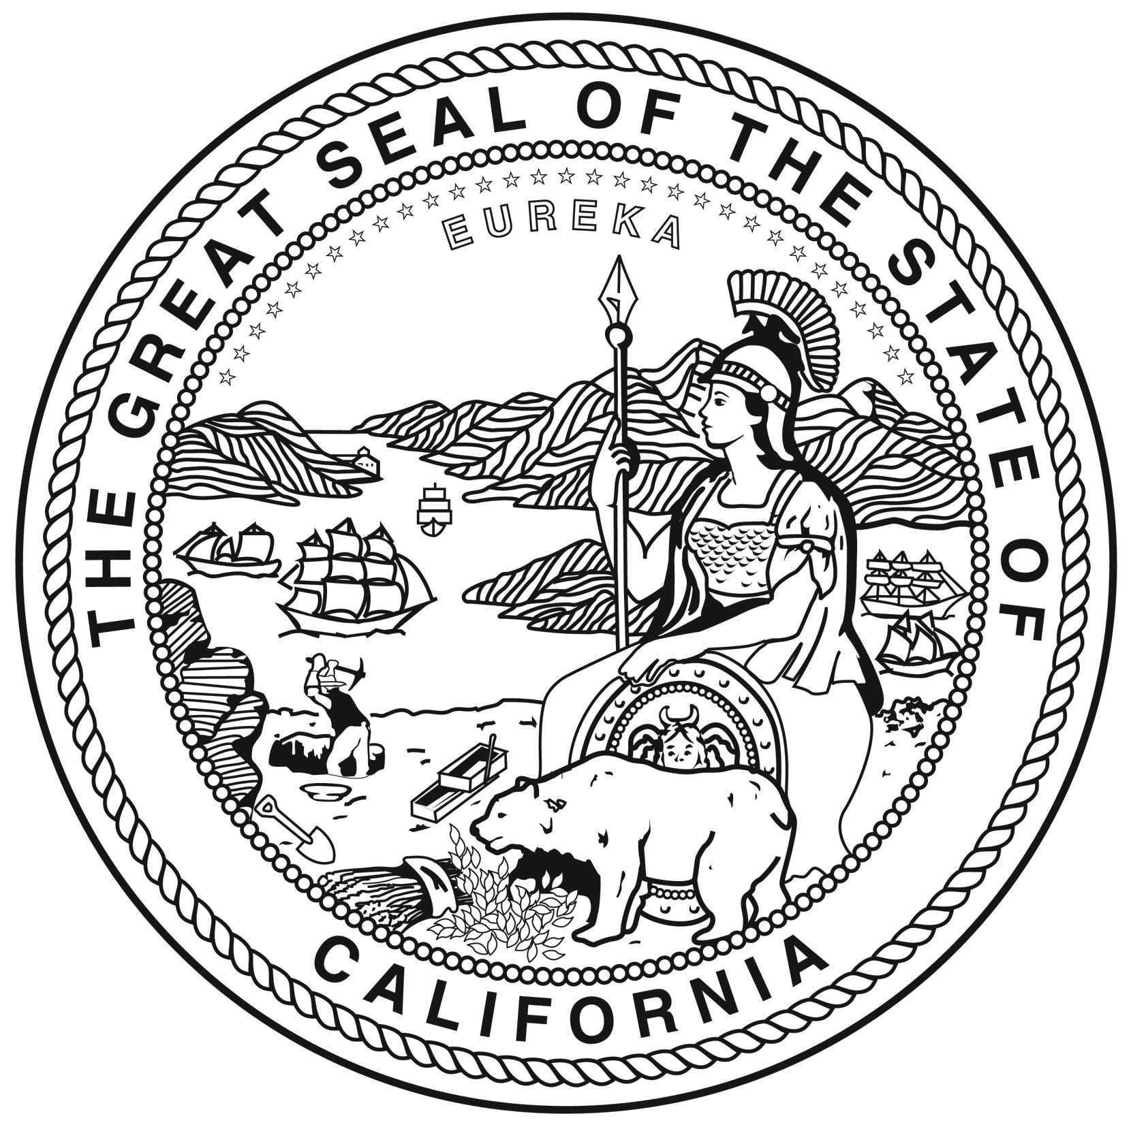



California African American Museum Filming Permit

Permit Packet

General Information and FAQ’s

Thank you for considering the California African American Museum for your next filming project. Below are some FAQ’s and General Information.
- When are Film Shoots allowed? Film shoots at the California African American Museum are only allowed during the museum’s closing hours at 5pm. In addition, film shoots are not allowed if it would interfere with any after school events at the California African American Museum and Special Events.
- Who is the primary contact? For questions regarding filming at the California African American Museum, please contact Steve Randle at (213) 744-7535
- What is the location fee? The California African American Museum does not charge a location fee.
- What buildings are considered to be part of the California African American Museum? All Galleries, Conference Center, Atrium and outdoor lawn areas.
- How long are productions companies typically allowed on California African American Museum property for film shoots? Because the California African American Museum is open 6 days a week, production usually lasts between 1-3 days with filming done mostly at night. Set up, filming and strike out should not interfere with California African American Museum’s guest experience.
- Does the California African American Museum have any fees? Yes. The California African American Museum does charge a Maintenance Fee to cover the cost of wear and tear of the building and utilities cost. You will also be responsible for overtime cost of extra California African American Museum staff that will be needed during filming. Fees will depend on the size and scope of the film shoot.

SPECIAL EVENT AND FILMING
PERMIT APPLICATION

TODAY’S DATE __________________________

CONTACT INFORMATION | EVENT INFORMATION
Company/Organization: | Type of Event:
Name of Applicant: | No. of Cast/Crew:
Billing Address: | No. of Extras:
City: State: Zip Code: | Other:
Office Phone: | No. of Vehicles:
Cell Phone: | No. Trucks/Trailers:
Email: | No. of RV’s:
Fax: | No. of Generators:
Other: | No. of Picture Cars:
 | No. of Catering:
 | No. of Lifts:

Music Amplification  NO  YES, Describe | Pyrotechnics/Smoke/Steam:  NO  YES, Please note: State Fire Marshall Al Adams 213-700-5884 and the Los Angeles Fire Department, Film Unit, 213-978-3672 must be contacted. An additional permit is required.

 | Start Date | End Date | Call Time | Wrap Time
Start up/Prep

Start/Shoot

Finish/Strike

Requested Locations
Please check box(es)
California African American Museum
Atrium
Conference Center
Patio
Lawn Area

Please attach any diagrams, etc that pertains to your special event and/or film shoot

Signature Print Name Date
California African American Museum
TERMS AND CONDITIONS
PAGE 1 OF 2

Indemnification: Permittee waives all claims against the state, its officers, agents and employees, for loss or damages caused by, arising out of, or in any way connected with the exercise of this permit.

Permittee agrees to indemnify, defend and save harmless the state, its officers, agents and employees, from any and all claims and losses accruing or resulting to any and all contractors, subcontractors, suppliers, laborers, and other person, firm or corporation furnishing or supplying work services, materials, or supplies in connection with the exercise of this permit, and from any and all claims and losses accruing or resulting to any person, firm or corporation who may be injured or damaged by Permittee in the exercise of this permit.

The State shall have the right of inspecting the premises covered by this permit at any or all times.

This permit shall not be assigned.

The State may terminate this permit at any time if Permittee fails to perform any covenant herein contained at the time and in the manner herein provided. The State agrees it will not unreasonable exercise this right of termination.

The parties hereto agree that the Permittee, its officers, agents and employees in the performance of this permit, shall act in an independent capacity and not as officers, employees or agents of the State.

No alteration or variation of the terms of this permit shall be valid unless made in writing and signed by the parties hereto.

Permittee agrees to maintain all State required insurance, as set forth in the California African American Museum’s insurance requirements. Permittee agrees to have a certificate of insurance liability in the form of a policy endorsement or rider from the insurance provider.

Permittee shall have proof of workers compensation insurance.

Permittee will not discriminate against an employee or applicant for employment because of race, color, religion, ancestry, set, age, national origin, or physical handicap.

Permittee agrees to comply with the terms and conditions contained in the attached exhibit(s), which terms and conditions are by the reference made a part thereof.

Permittee hereby agrees to comply with all the rules and regulations of the facility or institution subject to this permit. A copy of this permit is to be maintained at the location at all times.

___________________________________ ____________________________
Company Representative Signature Today’s Date

__________________________________ _____________________________
Print Name of Representative Title of Representative

California African American Museum
TERMS AND CONDITIONS
PAGE 2 OF 2

1. No electrical tie-ins allowed. You must provide your own generator

2. Generator(s) must be placed in open ventilated areas.

3. There are no wireless internet capabilities at the California African American Museum. The California African American Museum cannot provide wireless internet in any of our buildings.

4. You must provide your own port-a-potty for exterior filming. Accommodations may be made for interior film shoots.

5. No animals or pets are allowed in any California African American Museum facilities.

6. If food is being sold, a permit from the County of Los Angeles, Environmental Health is required. Call (323) 235-7009 for information.

7. All black rubber wheels on carts must be wrapped with a protective covering such as plastic to prevent wheel marks on concrete areas.

8. Cables, dolly track, and other potential hazards are to be shielded. If interiors are permitted, floors, walkways and walls will be protected with layout board and kraft paper.

9. Unless approved in advanced, any set construction, removal or covering of signs, painting, nailing, taping or any other alternations to the property are prohibited.

10. Removal of nonstructural items need to be done with the consent of the California African American Museum.

11. The California African American Museum has specific areas where there is a height/weight restriction. There are specific set up areas where height/weight restrictions need to be cleared.

12. Production personnel must confine themselves to the designated area that has been permitted/approved for production related activities.

13. Smoking permitted only in designated outdoor areas. Smoking is not permitted within 200 feet of all state owned buildings.

14. Alcohol is prohibited on State property and users may be issued a citation.

15. No ground staking on grass. Production companies must use sand bags or water barrels to hold tent/canopy in place.

16. If pyrotechnics and/or special effects (ie. Steam, smoke, etc) are to be used, a Fire Safety Officer is required. Call State Fire Marshal Al Adams at (213) 700-5884 and Los Angeles City Fire Department, Filming Unit at (213) 978-3670. The production company is responsible for obtaining the permit and securing a Fire Marshal. The Fire Marshall must be present for the entire duration of the shoot.

17. Cashier check or money order of full payment plus deposit must be received by the California African American Museum within 3 business days before the start of the set up/prep time indicated on the permit application.

18. Production companies are responsible for dumpster drop off and pick up. The California African American Museum is not responsible for any leftover props and/or trash that is not cleaned up by the end of the strike time as indicated on the permit form.

19. The California African American Museum is not responsible for any leftover props or equipment that will be used for next day shoots. All leftover props and equipment must be approved by the California African American Museum and covered with kraft paper and/or cardboard.

20. Any production company vehicles and/or trucks cannot block any trucks or vehicles from entering or exiting the loading docks.

21. Property must be restored to its original condition. Your security deposit will be refunded after a post event review is conducted of the premises to ensure that the site is clear of debris and there is no damage to the property plus any unexpected costs that occur due to the nature of the activity.

_________________________________ _________________________________
Company Representative Signature Today’s Date

________________________________ _________________________________
Print Name of Representative Title of Representative

INSURANCE REQUIREMENTS
FOR
SPECIAL EVENTS & FILMING

Anyone requesting to use the California African American Museum property must submit a current certificate of insurance in United States dollars, a certificate of insurance liability in the form of a policy endorsement or rider from the insurance provider, and proof of workers compensation insurance.

Insurance Requirements – Company shall comply with all requirements outlined in the (1) General Provisions section and (2) Contract Insurance Requirements outlined in this section.
- General Provisions Applying to All Policies
  - Coverage Term – Coverage needs to be in force for the complete term of the contract. If insurance expires during the term of the contract, a new certificate must be received by the State at least ten (10) days prior to the expiration of this insurance. Any new insurance must comply with the original contract terms.
  - Policy Cancellation or Termination & Notice of Non-Renewal – Contractor is responsible to notify the State within 5 business days of any cancellation, non-renewal or material change that affects required insurance coverage. New certificates of insurance are subject to the approval of the Department of General Services and the Contractor agrees no work or services will be performed prior to obtaining such approval. In the event Contractor fails to keep in effect at all times the specified insurance coverage, the State may, in addition to any other remedies it may have, terminate this Contract upon the occurrence of such event, subject to the provisions of this Contract.
  - Premiums, Assessments and Deductibles – Contractor is responsible for any premiums, policy assessments, deductibles or self-insured retentions contained within their insurance program.
  - Primary Clause – Any required insurance contained in this contract shall be primary, and not excess or contributory, to any other insurance carried by the State.
  - Insurance Carrier Required Rating – All insurance companies must carry an AM Best rating of at least “A–” with a financial category rating of no lower than VI. If the Contractor is self-insured for a portion or all of its insurance, review of financial information including a letter of credit may be required.
  - Endorsements – Any required endorsements requested by the State must be physically attached to all requested certificates of insurance and not substituted by referring to such coverage on the certificate of insurance.
  - Inadequate Insurance – Inadequate or lack of insurance does not negate the contractor’s obligations under the contract.
  - Use of Subcontractors - In the case of Contractor’s utilization of subcontractors to complete the contracted scope of work, contractor shall include all subcontractors as insured’s under Contractor’s insurance or supply evidence of subcontractor’s insurance to The State equal to policies, coverages, and limits required of Contractor.

The State of California must be named as an Additional Insured under the General Liability policy, Automobile Liability, Aircraft Liability, and Unmanned Aircraft Systems Liability if auto, aircraft and/or drones will be used.

- Contract Insurance Requirements
Contractor shall display evidence of the following on an Acord certificate of insurance evidencing the following coverages:
  - Commercial General Liability – Contractor shall maintain general liability on an occurrence form with limits not less than $2,000,000 per occurrence for bodily injury and property damage liability combined with a $2,000,000 annual policy aggregate. The policy shall include coverage for liabilities arising out of premises, operations, independent contractors, products, completed operations, personal & advertising injury, and liability assumed under an insured contract. This insurance shall apply separately to each insured against whom claim is made or suit is brought subject to the Contractor’s limit of liability. The policy must name The State of California, its officers, agents, and employees as additional insured, but only with respect to work performed under the contract.
  - Automobile Liability – Contractor shall maintain business automobile liability insurance for limits not less than $1,000,000 combined single limit. Such insurance shall cover liability arising out of a motor vehicle including owned, hired and non-owned motor vehicles. Should the scope of the Contract involve transportation of hazardous materials, evidence of an MCS-90 endorsement is required.
The policy must name The State of California, its officers, agents, and employees as additional insured, but only with respect to work performed under the contract.
  - Workers Compensation and Employers Liability – Contractor shall maintain statutory worker’s compensation and employer’s liability coverage for all its employees who will be engaged in the performance of the Contract. In addition, employer’s liability limits of $1,000,000 are required. By signing this contract, Contractor acknowledges compliance with these regulations.
A Waiver of Subrogation or Right to Recover endorsement in favor of the State of California must be attached to certificate.
  - Aircraft Liability – Contractor shall maintain Aircraft Liability with limits not less than $3,000,000 each occurrence for Bodily Injury and Property Damage liability combined. The policy must include The State of California, its officers, agents, employees and servants as additional insured, but only with respect to work performed under the contract. This endorsement must be supplied under form acceptable to the Office of Risk and Insurance Management. In the case of Contractor’s utilization of subcontractors to complete the contracted scope of work, contractor shall include all subcontractors as insured’s under Contractor’s insurance or supply evidence of insurance to The State equal to policies, coverages and limits required of Contractor.
  - Unmanned Aircraft Systems (UAS): Each UAS Operating entity must submit proof of Unmanned Aircraft Systems (UAS) insurance with a limit of at least $2,000,000. The certificate of insurance must include a separate policy endorsement showing proof of UAS coverage. A second (separate) endorsement must be submitted naming the State of California, its officers, agents and employees as Additional Insured. NOTE: Each of these two endorsements require a separate attachment to the certificate of insurance.

**Any required riders or endorsements requested by the State must be physically attached to all requested certificates of insurance and not substituted by referring to such coverage on the certificate of insurance.

***All insurance companies must carry an AM Best rating of at least “A-“with a financial category rating of no lower than VI.

Certificate Holder:
The State of California
700 Exposition Park Drive
Los Angeles, CA 90037

Please use the following wording:

The State of California, California Science Center, Office of Exposition Park Management,
California Science Center Foundation, Science Center School and Amgen Center for Science
Learning, California African American Museum, California African American Museum
Foundation, Natural History Museum of Los Angeles, Natural History Museum of Los
Angeles County Foundation, City of Los Angeles, Department of Recreation and Parks, the
Exposition Park Intergenerational Community Center, Los Angeles Memorial Coliseum
Commission, Trimana, and Matt Construction including its agencies, departments, officers, agents, employees and servants are named as an Additional Insured.

** Proof of Insurance is required 3 business days before the start of the set up/prep time indicated on the permit application. **

PARKING AND SECURITY

Coordinate Parking and Security through:

Office of Exposition Park Management
700 Exposition Park Drive, Los Angeles, CA 90037
Telephone: (213) 744 - 7659 and Fax: (213) 744 – 2225
www.expositionpark.org

The California African American Museum is not responsible for your parking and security needs. Daily parking at the parking lot is $15 per vehicle. A parking permit is required for overnight and/or vehicle/truck parking on State and Kinsey Drive. Additional fees may apply. Please contact the Office of Exposition Park Management for more information.

INVOICE

Item/Description | Unit/Hour | Unit cost | Total
Facility Maintenance Use
Event Coordinator
Building Engineer/Electrician
Custodian
Administrative Fee
SUBTOTAL
DEPOSIT (25%)
TOTAL

NOTE: The TOTAL along with the insurance must be received by the California African American Museum 3 business days before the start of the set up/prep as indicated on the permit application.
Your deposit will be returned within 30 days.

Cashier Check or Money Order made out to:

California African American Museum
Attention: State Accounting
600 State Drive
Los Angeles, CA 90037

Note: Parking and security must be arranged through the Office of Exposition Park Manager.

__________________________________ _____________________________________
Company Representative Signature Today’s Date

__________________________________ _____________________________________
Print Name of Representative Title of Representative

Day-Of Schedule

DAY OF, ON-SITE REPRESENTATIVES | NAME | CELL PHONE NUMBER
CAAM COORDINATOR
PARK SECURITY OFFICER
LOCATION SCOUT/MANAGER
COMPANY REPRESENTATIVE

PROPOSED SCHEDULE (As shown on the permit application):

 | Start Date | End Date | Call Time | Wrap Time
Start up/Prep

Start/Shoot

Finish/Strike

 | Actual Start Time | Actual End Time | CAAM Signature | Representative Signature
Start up/Prep
Start/Shoot
Finish/Strike

The California African American Museum reserves the right to charge additional fees for late end times. An extra $1000 an hour will be charged for each hour after the wrap time indicated on the permit form.

__________________________________ _____________________________________
Company Representative Signature Today’s Date

__________________________________ _____________________________________
Print Name of Representative Title of Representative

